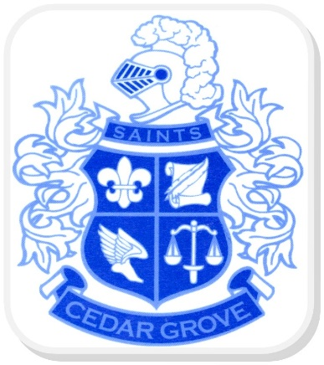

**C**edar **G**rove **H**igh **S**chool

Title I Annual Meeting

Parental involvement can make a huge difference in student achievement, so it should be a major focus of school improvement efforts.

Come learn about our Title I Program:

* Title I Budget
* Parents Right to Know
* Compacts
* Our School’s Parental Involvement Policy
* Assessments & Curriculum

We are excited to engage you!

**Tuesday, August 30, 2016**

**10:00 am & 5:30 pm**

Where:

Cedar Grove High School

2360 River Road

Ellenwood, GA 30294



P

Pamela J. Benford

*Principal*

Ferrun Johnson

*Assistant Principal*

Jairus Malcome

*Assistant Principal*

Dawn Price-Williams

*Assistant Principal*

Parents/Guardians

Cedar Grove HS

Parent Resource Center

is open daily

8:00 am – 4:30pm



Stop by the Parent Resource Center to learn about the resources available to support your child’s education



**For more information contact:**

Ronshavius Strozier

CGHS Title I Parent Liaison

Ronshavius_Strozier@dekalbschoolsga.org

(678) 874-4069

Rm. A357

2360 River Road

Ellenwood, GA 30294

cedargrovehs.dekalb.k12.ga.us